**Smart course Management**

**System in cloud**

Software Design Document

By

**Mr. Chaichan Suttee 542115016**

**Mr. Tanadol Parn-ong 542115021**

Department of Software Engineering

College of Arts, Media and Technology

Chiang Mai University

Project Advisor

________________________

**Mrs. Yun Rim Park**

# **Chapter One | Introduction**

## **Purpose**

The software design document (SDD) is written for describing the high level of software design, system architecture, database system and graphic user interfaces. Also consists of the users’ requirement. This document is an important thing for facilitating the developer team members to understand the direction of the system of Smart course management system in the cloud.

## **1.2 Software Scope**

This document describes the implementation details Smart course management system in the cloud. The system consists of five features. First feature is User registration, it covers on registration of Lecturer and Student. Second feature is Log in/Log out system, it covers on log in/log out of Lecturer account, Student account, and Administrator account. Third feature is Course management, it covers on management in courses of Administrator, and a accessing to courses by Lecturer and Student. Fourth feature is Assignment and quiz management, it covers on assigning, editing, deleting assignments or quizzes by Lecturer. Fifth feature is Taking assignments and quizzes, it covers on taking assignments and quizzes by Student. We will explain how to implement all features in the application by using the class diagram, sequence diagram for clarify and see overall big picture of the system.

## **1.3 Technology Review**

1.3.1 JavaScript

Technology description

JavaScript is a programming language known as the “script”. Translation operates on each command. It is commonly used as part of web browsers, which allow client-side scripts to interact with the user, control the browser, and change the content displayed on the We can add the JavaScript programming web pages to process data of both the display and receiving - transmitting. And that can interact with users immediately. JavaScript is also used in server-side programming and building games as well as desktop and mobile applications.

The selection of this technology

* We use JavaScript for calculating data, displaying, sending – receiving data for interacting with the user.
* JavaScript is easy to learn.

1.3.2 HTML5

Technology description

HTML5 is a language that was developed for use as a markup language. Website for writing the latest version is being developed by WHATWG (The Web Hypertext Application Technology Working Group). Several features have been added to allow developers to use more easily.

Alternative technology

- HTML4

The selection of this technology

- HTML5 can access sites easier than older version.

- HTML5 is support multimedia content.

- HTML5 is standardized for creating the user interface of website.

1.3.3 JavaScript Object Notation (JSON)

Technology description

JSON (JavaScript Object Notation) is a data interchange - format. It is based on a JavaScript programming language. JSON is a text format that is completely language independent. JSON uses sending and receiving data to and from different platforms.

Alternative technology

- XML

The selection of this technology

- JSON can send and receive data between different platforms.

- JSON is based on JavaScript, which the developers are familiar with.

# **Chapter Two | System Architecture**

DB

Web service

JSON

Web application

IIS



**Firefox web browser**

***Figure 1 Smart course management system in the cloud Architecture.***

The architecture of Smart course Management system in the cloud is shown in Figure 1. It consists the web application, which the user can access to the system by using a web browser. The system uses JSON for interchanging data between the web services and the web application.

# **Chapter Three | Detail Design**

## **3.1 Class Diagram Description**

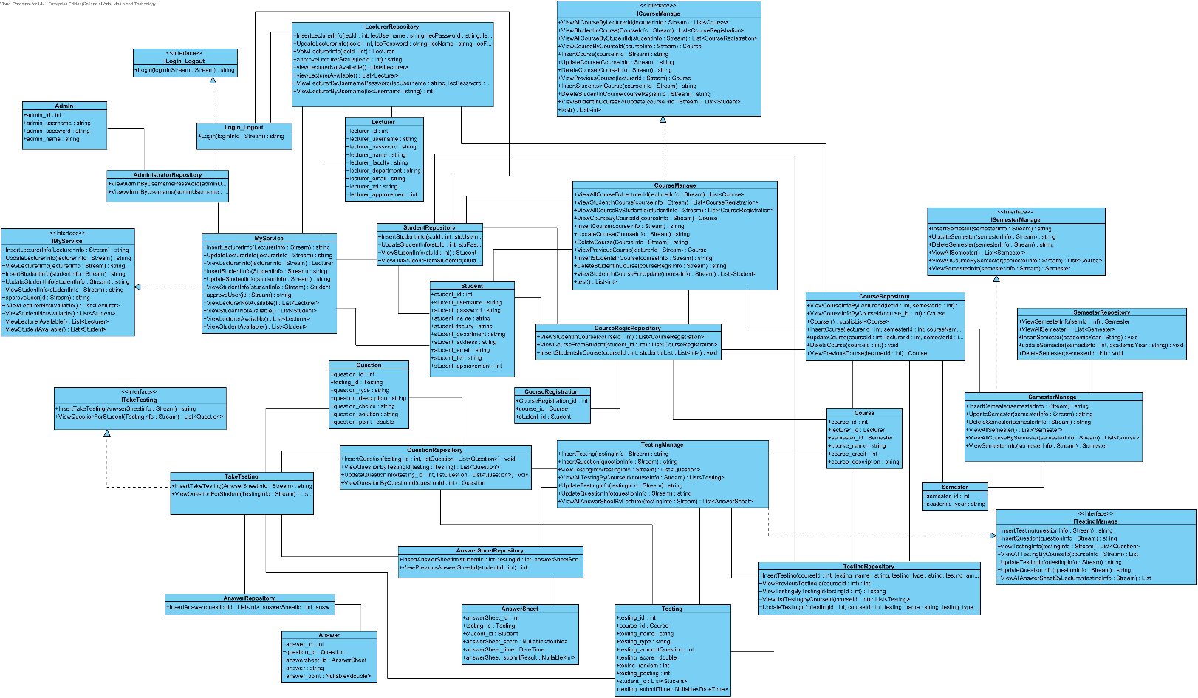

***Figure 2 Smart course management system in the cloud Class diagram.***

**Method Design**

Class Admin is Method Design Model-1 (MDM-1)

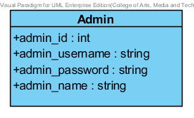

Attribute

|  |  |  |  |
| --- | --- | --- | --- |
| No. | Name | Description | Type |
| MDM-1.1 | admin _id | Unqiue Identifier of Administrator | int |
| MDM-1.2 | admin _username | Username of Administrator | string |
| MDM-1.3 | admin _password | Password of Administrator | string |
| MDM-1.4 | admin _name | Name of Administrator | string |

Class Lecturer is Method Design Model-2 (MDM-2)

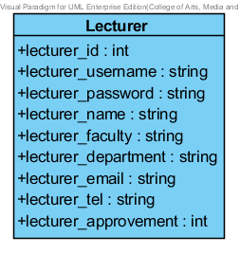

Attribute

|  |  |  |  |
| --- | --- | --- | --- |
| No. | Name | Description | Type |
| MDM-2.1 | lecturer_id | Unqiue Identifier of Lecturer | int |
| MDM-2.2 | lecturer _username | Username of Lecturer | string |
| MDM-2.3 | lecturer _password | Password of Lecturer | string |
| MDM-2.4 | lecturer _name | Name of Lecturer | string |
| MDM-2.5 | lecturer _faculty | Faculty of Lecturer | string |
| MDM-2.6 | lecturer _department | Department of Lecturer | string |
| MDM-2.7 | lecturer _address | Address of Lecturer | string |
| MDM-2.8 | lecturer _email | Email of Lecturer | string |
| MDM-2.9 | lecturer _tel | Tel of Lecturer | string |
| MDM-2.10 | lecturer _approvement | Approval status of Lecturer (1 is approve, 0 is not approve) | int |

Class Student is Method Design Model-3 (MDM-3)

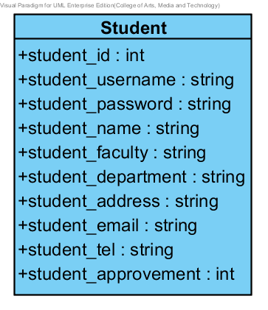

Attribute

|  |  |  |  |
| --- | --- | --- | --- |
| No. | Name | Description | Type |
| MDM-3.1 | student_id | Unqiue Identifier of Student | int |
| MDM-3.2 | student_username | Username of Student | string |
| MDM-3.3 | student_password | Password of Student | string |
| MDM-3.4 | student_name | Name of Student | string |
| MDM-3.5 | student_faculty | Faculty of Student | string |
| MDM-3.6 | student_department | Department of Student | string |
| MDM-3.7 | student_address | Address of Student | string |
| MDM-3.8 | student_email | Email of Student | string |
| MDM-3.9 | student_tel | Tel of Student | string |
| MDM-3.10 | student_approvement | Approval status of Student (1 is approve, 0 is not approve) | int |

Class Course is Method Design Model-4 (MDM-4)

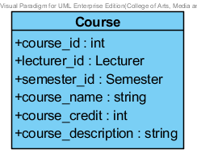

Attribute

|  |  |  |  |
| --- | --- | --- | --- |
| No. | Name | Description | Type |
| MDM-4.1 | course_id | Unqiue Identifier of Course | int |
| MDM-4.2 | lecturer_id | Object for identifying Lecturer | Lecturer |
| MDM-4.3 | semester_id | Object for identifying Semester | Semester |
| MDM-4.4 | course_name | Name of Course | string |
| MDM-4.5 | course_credit | Credit of Course | int |
| MDM-4.6 | course_description | Description of Course | string |

Class CourseRegistration is Method Design Model-5 (MDM-5)

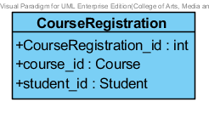

Attribute

|  |  |  |  |
| --- | --- | --- | --- |
| No. | Name | Description | Type |
| MDM-5.1 | CourseRegistration_id | Unqiue Identifier of Registration of Student into Course | int |
| MDM-5.2 | course_id | Object for identifying Course | Course |
| MDM-5.3 | student_id | Object for identifying Student | Student |

Class Semester is Method Design Model-6 (MDM-6)

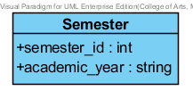

Attribute

|  |  |  |  |
| --- | --- | --- | --- |
| No. | Name | Description | Type |
| MDM-6.1 | semester_id | Unqiue Identifier of Semester | int |
| MDM-6.2 | academic_year | Value of semester | string |

Class Testing is Method Design Model-7 (MDM-7)

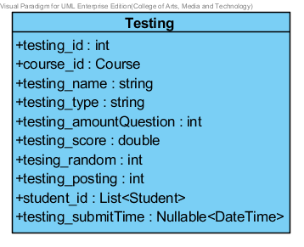

Attribute

|  |  |  |  |
| --- | --- | --- | --- |
| No. | Name | Description | Type |
| MDM-7.1 | testing_id | Unqiue Identifier of Testing | int |
| MDM-7.2 | course_id | Object for identifying Course | Course |
| MDM-7.3 | testing_name | Name of Testing | string |
| MDM-7.4 | testing_type | Type of Testing (1 is an assignment, 2 is a quiz) | string |
| MDM-7.5 | testing_amountQuestion | Amount of question in testing | int |
| MDM-7.6 | testing_score | Score of Testing | double |
| MDM-7.7 | tesing_random | Random status of testing (1 is random, 2 is not random) | int |
| MDM-7.8 | testing_posting | Post status of testing (1 is post, 0 is not post) | int |
| MDM-7.9 | student_id | List of Student objects in testing. It use for identifying accession to testing of a student. | List<Student> |
| MDM-7.10 | testing_submitTime | Deal line of time to submission | Nullable<Date Time> |

Class Question is Method Design Model-8 (MDM-8)

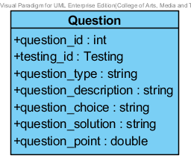

Attribute

|  |  |  |  |
| --- | --- | --- | --- |
| No. | Name | Description | Type |
| MDM-8.1 | question_id | Unqiue Identifier of Question | int |
| MDM-8.2 | testing_id | Object for identifying Testing | Testing |
| MDM-8.3 | question_type | Type of question (1 is a multiple choices question, 2 is a true/false question, 3 is a short answer question) | string |
| MDM-8.4 | question_description | Description of question | string |
| MDM-8.5 | question_choice | Description of choice in qestion  - Format of data  1. Multiple choice  Ex. choice1#$choice2#$choice3#$choice4  2. True/False  Ex. True#$False  3. Short answer  Ex. null | string |
| MDM-8.6 | question_solution | Solution of question  - Format data  1. Multiple choice  Ex. index of choice (1 or 2 or 3 or 4)  2. True/False  Ex. index of choice (1 or 2)  3. Short answer  Ex. null | string |
| MDM-8.7 | question_point | Score of question | double |

Class AnswerSheet is Method Design Model-9 (MDM-9)

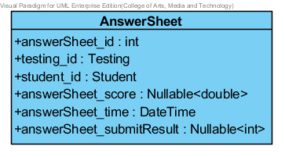

Attribute

|  |  |  |  |
| --- | --- | --- | --- |
| No. | Name | Description | Type |
| MDM-9.1 | answerSheet_id | Unqiue Identifier of Answer sheet | int |
| MDM-9.2 | testing_id | Object for identifying Testing | Testing |
| MDM-9.3 | student_id | Object for identifying Student | Student |
| MDM-9.4 | answerSheet_score | Score of answer sheet. Score can null status. | Nullable<double> |
| MDM-9.5 | answerSheet_time | Time of answer sheet in submission. | DateTime |
| MDM-9.6 | answerSheet_submitResult | Submit result of answer sheet (1 is early deal line of testing’s submission time, 0 is late deal line of testing’s submission time) | Nullable<int> |

Class Answer is Method Design Model-10 (MDM-10)

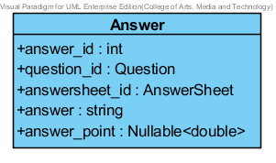

Attribute

|  |  |  |  |
| --- | --- | --- | --- |
| No. | Name | Description | Type |
| MDM-10.1 | answer_id | Unqiue Identifier of Answer | int |
| MDM-10.2 | question_id | Object for identifying Question | Question |
| MDM-10.3 | answersheet_id | Object for identifying Answer sheet | AnswerSheet |
| MDM-10.4 | answer | Description of answer | string |
| MDM-10.5 | answer_point | Score of correctness of answer | Nullable<double> |